Lewes District Food Partnership June/July 2023 Update
The focus in June was finishing the workshops for the Feeling the Pinch project and hosting the final Truth Hearing on the 27th of June which was attended by over 25 community representatives (more on this below). In July, work has continued developing the Grow Cook Eat network and we have been busy visiting projects and attending meetings across the District.
How are we addressing the priority areas?
How can we move beyond foodbanks and develop a sustainable approach to tackling food insecurity?
- Lewes District Emergency Food Network continues to meet monthly. We have welcomed new members from organisations that work alongside food support projects such as the Havens Hygiene Bank who are now linked in to support a number of other projects with hygiene products.
- We often invite representatives from other charities to come along and speak, I have recently been in touch with Health Watch, East Sussex Fire and Rescue Service and Brighton Women’s Centre about the support they can offer members of LD EFN.
- We have signed up as a Partner Member to Feeding Britain which is a national organisation campaigning for sustainable approaches to tackling food insecurity.
- Continuing to attend the Cost-of-Living Partners group (COL-PAG) hosted by LDC, Healthy Weights Partnership and Healthy Start Partnership.
Feeling the Pinch: Have Your Say Project
- We held the final two workshops in June for residents of Lewes District, then hosted a Truth Hearing where we invited people from the community who work with residents or are responsible for decision and policy making, such as town, district and county councillors, housing officers, charity workers, social prescribers. The hearing was well attended with over 25 community representatives. Link to blog post.
- We formed a number of Asks & Recommendations which have been received well by members of the council who support our work to increase community engagement with those that are facing food insecurity.
- A report of the project will be published and made available.
- I have done an interview with Radio Lewes and on the Lewes District Council’s Facebook live. As well as articles in the Tenants Voice Magazine and Sussex Express.
- Next steps: share the report widely with the public and professionals, hopefully opening doors to conversations with adult social care and housing officers. Pop-up exhibitions to show the stories and photos from the project. Seeking additional funding to continue the work and ensure the Asks & Recommendations are kept in mind by policy makers.
Dignified Food Support
- The draft principles have now been finalised and shared with nine national organisations including Feeding Britain, Your Local Pantry, IFAN and Sustain, and three local organisations including Faithworks and Brighton & Hove Food Partnership.
- Carl, Stef and Ronald have met with eight of these to get feedback and look at what they might be able to contribute to the work.
- Feedback was overwhelmingly positive and there is lots of enthusiasm to take this work forward.
- National stakeholder workshop to be held in September to finalise the principles and forming the National Alliance for Dignified Food Support.
- Further workshop planned for national food partnership coordinators to explore how FPs can be a mechanism for cascading the principles to grassroots organisations.
- Exploring potential for a bid to the National Lottery Bringing People Together fund to support further work including development of training resources and coordination of the alliance.
How can connections be fostered to promote community growing, cooking & eating?

- Gemma Mcfarlane has been working to develop the GCE network and to create a number of useful resources.
- She has been creating a database of kitchen spaces that are available to hire, of independent and/or local businesses available for catering. We will include these resources on the website as well as link to existing resources.
- GM has visited Peverells Community Garden in Seaford and I have been to Wallands School Allotment and back to Lovebrook Farm to hear about their progress.
- GM has been working closely with Seaford Head on a number of projects including Healthy Eating Week and a community garden on the school grounds.
- GM has been working on a newsletter to showcase Grow Cook Eat opportunities across Lewes District including volunteering opportunities, events and workshops. This will be a printed resource which will be available at various locations including libraries, food banks, family hubs etc to encourage more people to get involved.
- As well as an active Whatsapp group we stay connected via quarterly meetings at different projects in Lewes District. In June we visited Peacehaven Community Orchard and shared updates.
Other key themes – promoting local food businesses and food sustainability

- Visit to Newhaven Harbour to hear about their development plans with help from the Levelling Up Fund
- Attended a Low Carbon Lunch at East Sussex County Hall in Lewes and spoke to the Environment Team. Unfortunately, it seemed that food is not high on the agenda in terms of how to transition to a net zero-carbon council as it is seen as a national issue or one that doesn’t fit neatly in to the Environment Departments remit at ESCC.

East Sussex County-wide Strategy
- The four food partnerships in East Sussex (Wealden, Hastings & Rother, Eastbourne and Lewes District) met with the commissioner of the partnerships, Anna Card, and Robert Laslett both from East Sussex County Council, as well as Helen Star-Keddle and Alex Britten-Zondani from Food Matters to discuss county-wide strategies for the direction of the partnerships. We have identified key priority areas that each partnership will move forward on.
- LDFP’s priority areas are Food Inequality and Health which we will work alongside Hastings & Rother and Wealden with. Food Procurement & Catering and Community Growing, Land Use and Planning are joint strategic areas for LDFP and Eastbourne Food Partnership.
- Good Food for East Sussex is the umbrella name for the four food partnerships but will be managed internally by ESCC with it’s own mailing list to promote the work we are doing.
- Good Food for East Sussex will be hosting a Food Month in October celebrating and promoting ‘foodie’ events and hosting an event to bring people together. Get in touch if you’d like to know more.

Steering Group
We have welcome three new members to our Steering Group: Nir Halfon Head of Horticulture at Plumpton College and Miemei Neethlin-Taylor Head of Higher Education at Plumpton College and Emily O’Brien Green Party Councillor and Cabinet Member for Climate, Nature & Food Systems at LDC. The steering group now consists of 14 active members engaged in the strategic development of LDFP.
Steering group meetings are quarterly with one held in July to discuss the Bronze Award application for LDFP and the food summit in October.
Other
- Attended the Plumpton College EDI fair and gave a talk about food insecurity and dignity approaches. I have been invited back for further workshops and talks with students and lecturers.
- Newsletter sent to 200+ on the mailing list with lots of useful links, blog posts, volunteering and work opportunities and grant information.
- Attended the Day of Celebration in Westminster for SFP Coordinators and MPs.

Next steps for August
- Work with the East Sussex food partnerships on county-wide strategies, initiating conversations with county council officers to see if there is take up of a Co-Chair approach.
- Meeting with Wealden and Hastings & Rother and Stuart Ramsbottom from NHS on Food Inequality and Health county-wide strategies
- Meeting with Jade from Real Farming about their work on Advocacy and Food Insecurity and how we may be able to collaborate
- Planning the food summit in October at Plumpton College as well as Good Food for East Sussex month
- Continue the work of the Feeling the Pinch Project as outlined above
- Meet with new projects to engage them in the GCE network including Hospitable Environment, continue building the relationship with Table Talk.
- Funding opportunities for projects in Lewes District that address food poverty from Household Support Fund 4
- Meet with Ouse Valley Climate Action to discuss collaboration around food sustainability issues and areas our work intersects
- Continue working on the Bronze Award application

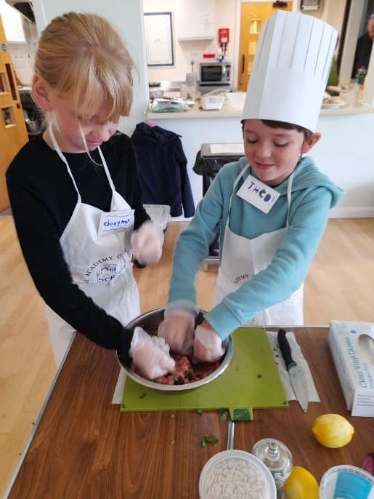
Cookery Workshop for kids – partnership between Fitzjohns Foodbank and Table Talk Foundation
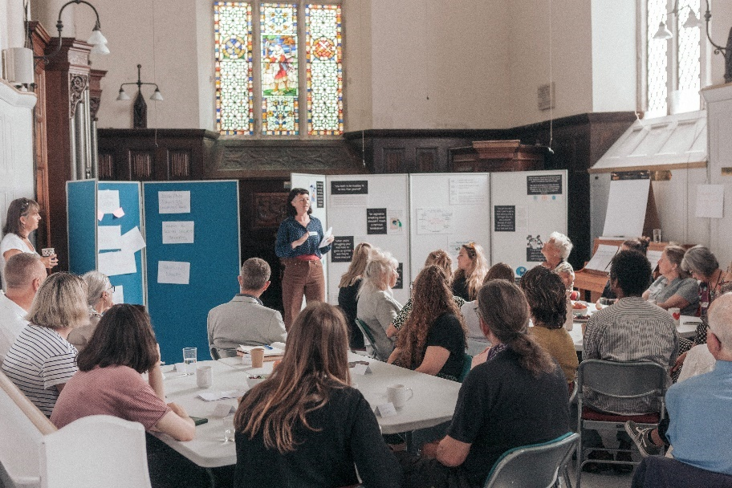
Feeling the Pinch: Have Your Say Truth Hearing
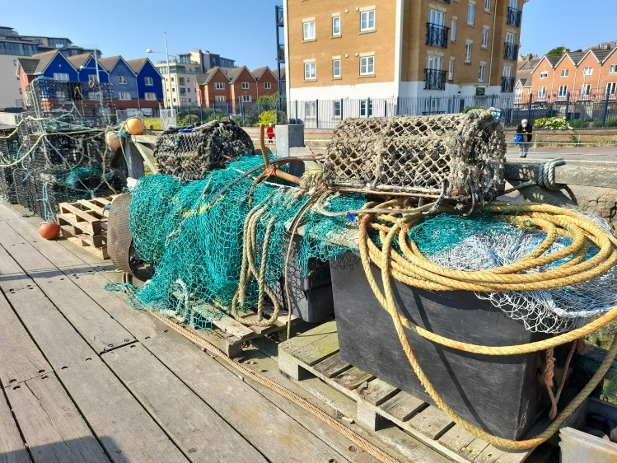
A visit to Newhaven Harbour

